SYSTEM ANALYSIS AND DESIGN (SAD) DOCUMENT

Project Title: HRU Ask — Haramaya University Q&A Forum

Subtitle
A Stack Overflow–style platform for HRU students to ask, answer, and learn together.

Tagline
“Ask. Learn. Grow.”

1. INTRODUCTION

1.1 Purpose
The purpose of HRU Ask is to provide a web-based platform for students of Haramaya University (HRU) to ask academic and technical questions, share answers, and collaborate. It aims to improve learning by enabling students to learn from each other’s knowledge and experiences.

1.2 Scope
HRU Ask allows users to:
- Register and login
- Post questions
- Post answers
- Comment on questions and answers
- Vote on questions and answers
- Accept the best answer
- Tag questions
- Search questions
- View user profiles and reputation

1.3 Objectives
- Create a community-driven knowledge base for HRU students.
- Improve student learning and collaboration.
- Provide a secure and scalable platform for Q&A.
- Implement features similar to Stack Overflow.

2. SYSTEM OVERVIEW

2.1 System Architecture
HRU Ask follows a full-stack architecture:
- Frontend: React
- Backend: Node.js + Express
- Database: MySQL
- Authentication: JWT
- Deployment: Render / Heroku / Vercel

Architecture Diagram
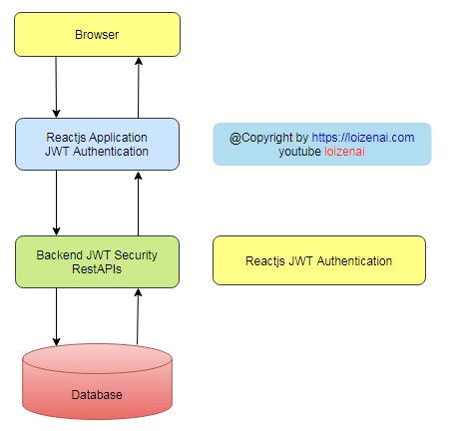

3. REQUIREMENTS ANALYSIS

3.1 Functional Requirements
- User Registration
- User Login
- Create Questions
- Create Answers
- Comment on Questions & Answers
- Upvote/Downvote Questions & Answers
- Accept Best Answer
- Tag Questions
- Search Questions
- View User Profile & Reputation
- Pagination for Questions List

3.2 Non-Functional Requirements
Requirement Type | Description
Performance | Fast response and scalable database
Security | Password hashing, JWT, input validation
Usability | Responsive UI, easy navigation
Reliability | Data consistency and error handling
Maintainability | Clean functional architecture
Scalability | Indexing, pagination, caching

4. SYSTEM DESIGN

4.1 Database Design (MySQL) — Normalized (3NF)

4.1.1 ER Diagram

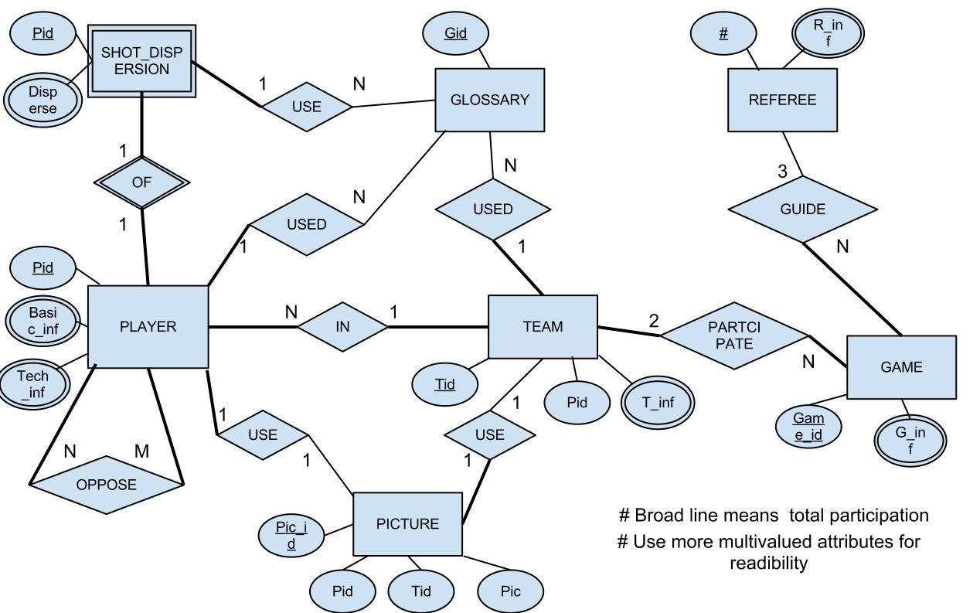

4.1.2 Tables

users
Column | Type | Notes
user_id | INT PK AUTO_INCREMENT
username | VARCHAR(50) UNIQUE
email | VARCHAR(100) UNIQUE
password | VARCHAR(255)
created_at | TIMESTAMP DEFAULT CURRENT_TIMESTAMP

user_profiles
Column | Type | Notes
profile_id | INT PK AUTO_INCREMENT
user_id | INT FK | references users(user_id)
bio | TEXT | nullable
avatar_url | VARCHAR(255) | nullable
reputation | INT DEFAULT 0

questions
Column | Type | Notes
question_id | INT PK AUTO_INCREMENT
user_id | INT FK | who asked
title | VARCHAR(255)
description | TEXT
created_at | TIMESTAMP DEFAULT CURRENT_TIMESTAMP
updated_at | TIMESTAMP | nullable

answers
Column | Type | Notes
answer_id | INT PK AUTO_INCREMENT
question_id | INT FK
user_id | INT FK
answer | TEXT
created_at | TIMESTAMP DEFAULT CURRENT_TIMESTAMP
updated_at | TIMESTAMP | nullable
is_accepted | BOOLEAN DEFAULT FALSE

comments
Column | Type | Notes
comment_id | INT PK AUTO_INCREMENT
post_type | ENUM('question','answer')
post_id | INT | question_id or answer_id
user_id | INT FK
comment | TEXT
created_at | TIMESTAMP DEFAULT CURRENT_TIMESTAMP

tags
Column | Type | Notes
tag_id | INT PK AUTO_INCREMENT
name | VARCHAR(50) UNIQUE

question_tags
Column | Type | Notes
id | INT PK AUTO_INCREMENT
question_id | INT FK
tag_id | INT FK

votes
Column | Type | Notes
vote_id | INT PK AUTO_INCREMENT
user_id | INT FK
post_type | ENUM('question','answer')
post_id | INT | question_id or answer_id
value | TINYINT | +1 or -1
created_at | TIMESTAMP DEFAULT CURRENT_TIMESTAMP

5. API DESIGN (REST)
Note: Backend is functional (no OOP).

5.1 Authentication Routes
Endpoint | Method | Description
/auth/register | POST | Register user
/auth/login | POST | Login user and return JWT

5.2 User Routes
Endpoint | Method | Description
/users/:id | GET | Get user profile
/users/:id/questions | GET | Get user's questions
/users/:id/answers | GET | Get user's answers

5.3 Questions Routes
Endpoint | Method | Description
/questions | GET | Get all questions (pagination)
/questions | POST | Create question
/questions/:id | GET | Get question by ID
/questions/:id | PUT | Update question
/questions/:id | DELETE | Delete question
/questions/:id/accept | POST | Accept an answer

5.4 Answers Routes
Endpoint | Method | Description
/answers | POST | Create answer
/answers/:id | PUT | Update answer
/answers/:id | DELETE | Delete answer
/questions/:id/answers | GET | Get answers for a question

5.5 Comments Routes
Endpoint | Method | Description
/comments | POST | Create comment
/comments/:id | DELETE | Delete comment
/posts/:id/comments | GET | Get comments for question or answer

5.6 Votes Routes
Endpoint | Method | Description
/votes | POST | Vote (upvote/downvote)

6. BACKEND DESIGN (FUNCTIONAL)

6.1 Folder Structure
backend/
│
├── controllers/
│ ├── authController.js
│ ├── userController.js
│ ├── questionController.js
│ ├── answerController.js
│ ├── commentController.js
│ └── voteController.js
│
├── routes/
│ ├── authRoutes.js
│ ├── userRoutes.js
│ ├── questionRoutes.js
│ ├── answerRoutes.js
│ ├── commentRoutes.js
│ └── voteRoutes.js
│
├── middleware/
│ └── authMiddleware.js
│
├── db/
│ └── dbConfig.js
│
└── server.js

7. FRONTEND DESIGN

7.1 Pages
Page | Description
Home | List questions
Question | View question + answers + comments
Ask | Add question
Login | User login
Register | User registration
Profile | User reputation & posts
Tags | View all tags

7.2 Components
- Navbar
- QuestionCard
- AnswerCard
- CommentBox
- VoteButton
- TagBadge
- SearchBar
- Pagination

8. SECURITY DESIGN

8.1 Authentication
- JWT for authentication
- Protected routes

8.2 Password Security
- bcrypt hashing

8.3 Input Validation
- Validate all inputs to prevent SQL injection

8.4 Additional Security (Optional)
- Rate limiting
- HTTPS deployment

9. PERFORMANCE & SCALABILITY

9.1 Indexing
- Index on user_id, question_id, tag_id

9.2 Pagination
- Use limit and offset for question listing

9.3 Caching (Optional)
- Cache top questions for faster load

10. TESTING STRATEGY

10.1 Unit Testing
- Test controllers and database functions

10.2 Integration Testing
- Test API endpoints using Postman

10.3 Manual Testing
- UI testing for all pages

11. DEPLOYMENT PLAN

Backend
- Deploy on Render / Heroku

Frontend
- Deploy on Vercel

Database
- Use PlanetScale / AWS RDS

)
Just say what you need next.

